Ideation Phase
Date | 16 June 2025
Team ID | LTVIP2025TMID56090
Project Name | FreelanceFinder: Discovering Opportunities, Unlocking Potential
Maximum Marks | 4 Marks
Brainstorm & Idea Prioritization Template

Brainstorm & Idea Prioritization Template:
Brainstorming provides a free and open environment that encourages everyone within a team to participate in the creative thinking process that leads to problem solving. Prioritizing volume over value, out-of-the-box ideas are welcome and built upon, and all participants are encouraged to collaborate, helping each other develop a rich amount of creative solutions.

Step-1: Team Gathering, Collaboration and Select the Problem Statement

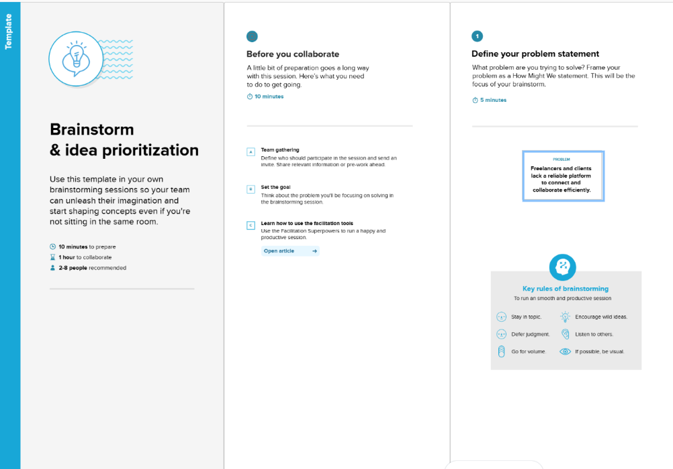

Step-2: Brainstorm, Idea Listing and Grouping

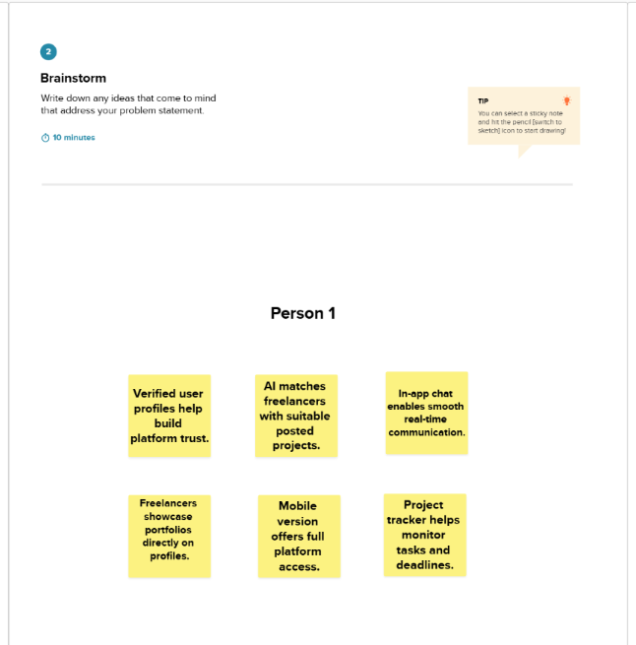
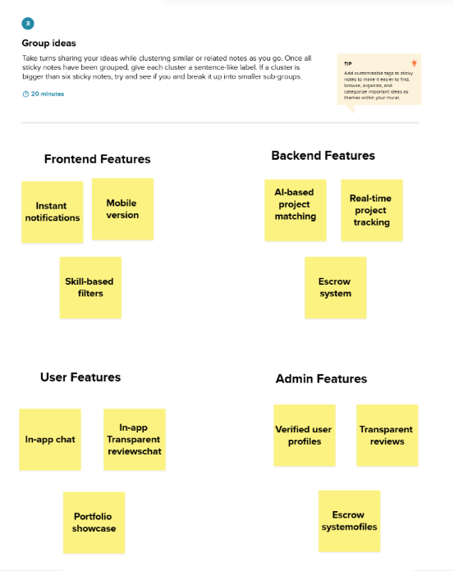

Step-3: Idea Prioritization
